**Greensborough Primary School—2062**

**130 Grimshaw Street**

**Greensborough 3088**

**Phone: 9435 1496 OSHC: 8564 9000**

**Email: greensborough.ps@edumail.vic.gov.au**

**Website:** [**www.greensborough.vic.edu.au**](http://www.greensborough.vic.edu.au)

|  |  |
| --- | --- |
| *Borough Bulletin*  *2 August 2018* | |
| *Monday 6 August 2018* | ***Science Week – Game Changers and Change Makers*** |
| *Tuesday 7 August 2018* | ***Robotics Demonstration*** |
| *Thursday 9 August 2018* | ***Senior School Science Talks*** |
| *Friday 10 August 2018* | ***Student Voice Conference with School Captains*** |
| *Monday 13 August 2018* | ***Greensborough Primary School Council Meeting at 7:00pm*** |
| *Tuesday 14 August 2018* | ***Athletics Tryouts – Grade 3 to 6 – Willinda Park Athletics Ground – 9:00am to 1:30pm*** |
| *Tuesday 14 August 2018* | ***Art Show commences – 3:00pm to 7:00pm*** |
| *Wednesday 15 August 2018* | ***Art Show – 3:00pm to 7:00pm***  ***Special Visitor’s Day P – 2*** |
| *Saturday 18 August 2018* | ***140 Year Celebration Open Day & Art Show – 2:00pm to 4:00pm*** |
| *Tuesday 21 August 2018 to Friday 24 August 2018* | ***Book Fair – Library*** |
| *Wednesday 22 August 2018* | ***Book Week Multi-Age Day*** |
| *Friday 24 August 2018* | ***Book Week Parade*** |
| *Monday 27 August 2018* | ***Poetry Winner announced at Assembly*** |
| *Thursday 30 August 2018* | ***District Athletics (all day)*** |
| *Friday 31 August 2018* | ***Father’s Day Stall*** |
| *Thursday 6 September 2018* | ***Walkathon*** |
| *Friday 7 September 2018* | ***Premiers Reading Challenge closes*** |
| *Monday 10 September 2018* | ***School Council Meeting at 7:00pm*** |
| *Tuesday 11 September 2018* | ***Southern Cross Recycling*** |
| *Friday 21 September 2018* | ***Last Day of Term – 1:30pm Finish*** |

**Principal’s Report**

Our 140th birthday celebration is almost upon *us* ***( Saturday August 18th 2-4pm)*** and we are looking forward to our present and past students, staff and community members revisiting Greensborough Primary and sharing memories of their school life. I’m sure they’ll be amazed at the changes that have taken place over time – not only with the physical buildings and grounds but with school programs. In the last eight years alone, there have been many changes with the installation of the outdoor learning area, cosy coop, the gagaball pit, outdoor seating, sandpits, chess board, art installations, the indoor Japanese garden and rabbits in the ferneries, the Friendship Tree, refurbishment of cricket nets, Library outdoor learning area, extension of hall, windows installed in Library and Curiosity Corner, new fencing on corners of school to enhance visibility, garden beds internally and externally, and the list goes on. School programs have also greatly improved with the introduction the Art Show, Choir, STEM, (Science, Technology, Engineering and Mathematics), Magic Maths, Spelling Mastery, VCOP and Big Write, Robotics and Coding classes, extension programs in Literacy, Mathematics, Visual Arts, Science and Ukulele, and intervention programs in Literacy and Numeracy, and establishment of Parents and Friends.

We almost take for granted now, our robotics programs and use of digital technologies, including ipads, notebooks, microscopes and cameras. Students today use vastly different tools from past eras and this was highlighted when Greensborough Historical Society helped us contact past students who visited grades and talked about school life in their era. Students in Grade Five and Six were particularly interested in Eric B’s stories about the use of the cane and strap, and travelling to Interschool Sport sitting in a trailer, while the talented players sat in the car with the teacher. The consensus was that school today is a better place!

As students learn about the history of Greensborough and our school, we acknowledge they are part of many “firsts” that make their time at GPS memorable. Last week as we celebrated NAIDOC Week, our school captains acknowledged the traditional owners of the land our school is on, the Wurundjeri Willam people – this is now a protocol that will be included in all our school assemblies. A highlight of the week was when Lee, father of Kelvin, Vanessa and Viviarna, played the didgeridoo at assembly.

Another “first” is our hosting of five students from China for a short term study program. This program is a great opportunity for cross cultural exchange and extension of language skills.

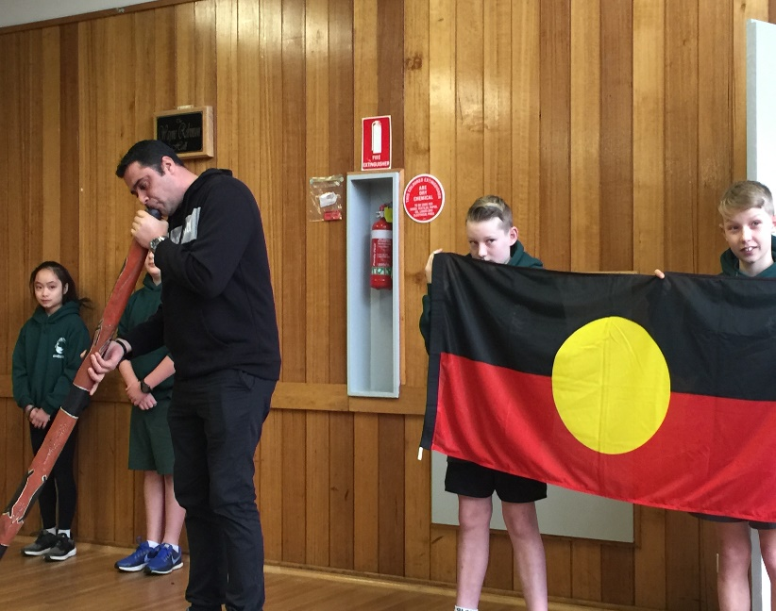

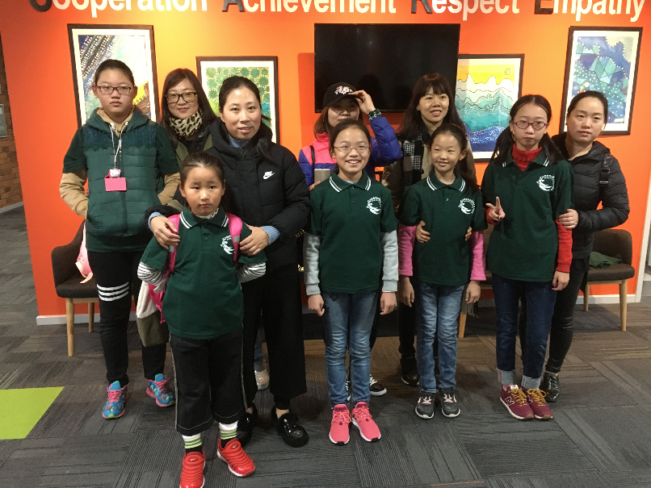

**140 Year Reunion and Celebration**

As mentioned in our last newsletter, Odette has been rehearsing songs for grades to perform at our 140 year reunion and celebration. Attached to this newsletter is a flyer with the day’s program, including times that grades are scheduled to perform. If any students are unable to attend due to prior commitments, please let your child’s class teacher know.

[](https://www.google.com.au/url?sa=i&rct=j&q=&esrc=s&source=images&cd=&cad=rja&uact=8&ved=2ahUKEwjKv-T04sjcAhUDUt4KHSmeAk4QjRx6BAgBEAU&url=https://www.heraldsun.com.au/leader/inner-east/reservoir-driver-gets-behind-the-wheel-for-charity-for-one-last-big-road-trip/news-story/145ebc44e80e1061eacd1a3d3ff02865&psig=AOvVaw3I_06xuyUMHmrpsxoH688i&ust=1533107037350245)A great deal of preparation has gone into organising this day and we are very fortunate that Lachie Pitman from Aussie Home Loans, (which was based in Greensborough and has now moved to Northcote), has agreed to support us on this day.

Lachie will provide a sausage sizzle and is hoping to arrange for some themed Variety Club Bash Cars to be present, to add to the festivities. Along with the free sausage sizzle, tea, coffee and light refreshments will also be provided.

**Term Events**

Once again we have a very full term with many extracurricular events that enhance our regular class programs. Janet has attached a flyer for the ***Art Show*** later in this newsletter and we are looking forward to extended family members attending and viewing the artwork of our very talented students. The Art Show has been extended this year so that the artwork will still be on display during our 140th celebration on Saturday 18th August.

Jen Farley is busy organising activities for ***Book Week***, August 20th – 24th which is always a highlight of our school year. Jen has once again organised a multi-age day where students across the school will work together on activities inspired by the shortlisted books. This will be followed by our Book Parade on Friday 24th August, where students and staff dress as book characters. I know many students are already working on their costumes and we invite parents and family members to come along and join in the fun.

Salima has organised activities to promote Science Week and we are looking forward to Dr Chris McCarthy’s presentation on humanoid robotics and Dr Lisa Mielke’s talk on what it’s like to have a career in Science.

Thank you to Salima, Janet and Jen for coordinating these exciting school events.

**School Funding - Updating Family Details**

There are various factors that impact on school funding and these include parents’ occupation and education levels. Basically higher levels of education and management/professional positions, result in less funding for schools. If family circumstances have changed and children are no longer residing with both parents, this also impacts funding levels. To ensure our 2019 funding level is accurate, we need to make sure our family details are correct and up to date on our computer system. Therefore if your employment or family situation have changed from when you filled in your child’s enrolment form, please let the office know by Monday August 6th. For example if you are presently busy with home duties, have made a career change or are unemployed, please let us know so that the Department has accurate information to determine our 2019 budget.

**Mini Networks**

Each term in week four, schools in the Banyule/Nillumbik Network come together for Professional Development opportunities and share their expertise with teachers from other schools. We congratulate Erin and Salima who will be hosting sessions this term. Salima will present on Inclusion and Universal Design for Learning (UDL) which is a research-based framework that can be utilised to help plan inclusive lessons in any subject. Erin will present The Big Write and VCOP (Vocabulary, Connectives, Openers, Punctuation) resource session. Both sessions are expected to be fully booked out.

**School Partnerships with Aussie Home loans and Nelson Alexander Real Estate**

We are very pleased to announce the establishment of ongoing partnerships with Aussie Home Loans and Nelson Alexander Real Estate Agency. I’d like to thank parents Tracey H and Stephanie T., for making the initial introduction to these local companies for us and we are looking forward to a long and mutually advantageous relationship.

As stated above, Lachie Pitman from Aussie Home loans has pledged support for our 140 year celebration and has also generously offered to pay the school $250 for every home loan referred to Aussie or taken out by parents and friends. Whilst the office has relocated to Northcote, several staff members live locally. Lachie has also donated a fridge and microwave to the school canteen and indicated Aussie will assist with prizes and attendance at future Trivia Nights.

Margaret and I also met with Andrea Dix from Nelson Alexander real estate agency who have agreed to supply boards promoting school events and programs and support fund raising events. They have also generously offered to donate 10% of the office commission for a property that they list, and sell, for any member of the school (i.e. parents, teachers).

Both Aussie and Nelson Alexander have offered to help with publicity and marketing for Greensborough Primary and we are looking forward to rewarding long term relationships. Any families who engage with either company should declare their connection to GPS.



**2019 Prep Enrolments**

This term we will begin planning in earnest for staffing and grades for 2019. So if you know anyone who is coming to Greensborough Primary next year, please advise them to register their details as soon as possible, (this includes siblings of current students) as we will be finalising numbers in the Prep class.

***Angela Morritt***

**Principal**

**Student Accounts**

On Friday, student accounts will be sent home which itemise all costs incurred on behalf of your child which, by the Government’s Parent Payment Policy, are Parents’ responsibility for payment. These charges include, camps, excursions, and Subject Contributions which covers all books and stationary items purchased specifically for your child’s use and a host of activities and experiences your child engages in. The charges for the Term Four Swimming program as well as the Grade Six Graduation and Grade Six Big Day Out have also been included. For those families who met the criteria for CSEF funds (Camp Swimming Excursion Funds), where there are funds remaining in your account, these have been used to cover the cost of the swimming program for your child. We work extremely hard to maximise the value of every dollar that comes into the school and appreciate the support of families promptly paying school accounts. We would especially appreciate the 2018 Subject Contribution Charge being fully paid by the end of Term Three and, if this poses any difficulties, please contact the office to let us know. (*Any payments made this week may not yet be reflected in the statements but please contact the office if you would like clarification of balances).*

**Swimming**

The dates for the Term Four Swimming program are: Friday October 26th, November 2nd , 9th, 16th, 23rd, 30th and December 7th. As has been the case in previous years we will be walking to Water Marc, with an exact time-table of lessons published in the newsletter closer to the date. The cost of the Swimming program is $44.00 which covers six pool entries (the school covers the cost of swimming tuition) and the special water activity day in the last week of the program. With the concerning rate of childhood drownings, increased emphasis has been placed on schools to offer a quality water safety program. If you do not wish for your child to take part in the swimming program please contact the office so you can sign a form stating that, whilst a swimming program was offered by the school, it was your decision that your child not participate.



**Friday Fruit**

We continue to be overwhelmed by the enthusiasm of students for lunchtime fruit and the generosity of Woolworths Greensborough in supplying three large boxes of fruit each week.



**Magazine Toy Reviews**

We were recently given the opportunity to put in an expression of interest in being involved in a program where students could trial and then write a review of new toys for the Just Kidding Magazine (a publication that is distributed through schools). We were very lucky to be selected to be involved in the program and are eagerly looking forward to our first delivery of toys which, after the review process, the school is able to keep. As well as the students’ written reviews, we are asked to submit photos of students trialling the toys so, whilst we already have media permission forms signed, I will additionally contact parents of students involved to gain their specific approval for their child’s involvement in the program.

**Home Reading**

As was explained in the last newsletter we are beginning a program to encourage, not only children reading at home but parents or siblings reading to children as well. Being exposed to the vocabulary, dialogue and structures of quality picture fiction gives children the potential to extend not only their reading capabilities but also their oral language and written skills. We have purchased a significant number of new titles which we are in the process of stamping and cataloguing so students in Grades Prep-2 will be able to bring home not only the decodable text at their level which they can read independently, but also another text that we hope Mums, Dads, siblings or extended family members can read and share with them. We are hoping to have the resources ready to commence this program at the start of next week.

**3-6 Athletics Carnival**

We are hoping for a sunny day on Tuesday 14th August when we hold our annual Athletics Carnival for all our Grade 3-6 students. The day will begin at Willinda Park Athletics Track at 9:30 and conclude by 1pm. Parents are most welcome and if you are able to offer your assistance please leave your name and number with Mehgan at the office or see  me in Room 7. All help is greatly appreciated.

We look forward to an enjoyable, active morning.

**Alison Gibson**

Sports Co-Ordinator



**Prep-2 Little Athletics session**

On Monday 30th July, the students in Prep and Grades 1/2 participated in a Little Athletics session with Terry Knape from Diamond Valley Athletics Club, who kindly offered his time to teach the students some fundamental skills.

The Prep students practised high knees and talked about the main parts of the body that are important for running such as legs, arms and eyes. They also practised bouncing balls.

The 1/2 students received explicit instruction on running techniques and how to start a race. They also worked on their long jump skills and how to land in a motorbike position.

**Mrs Darling**

PE teacher

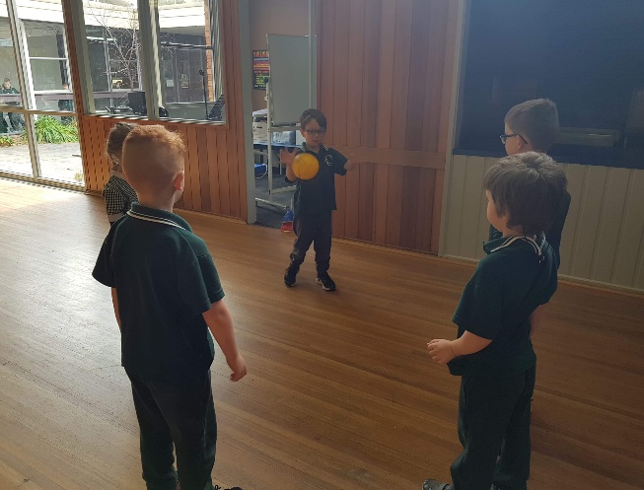

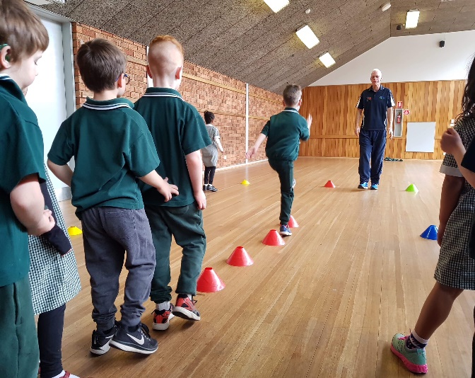

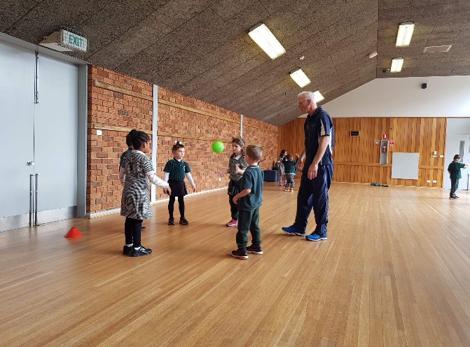

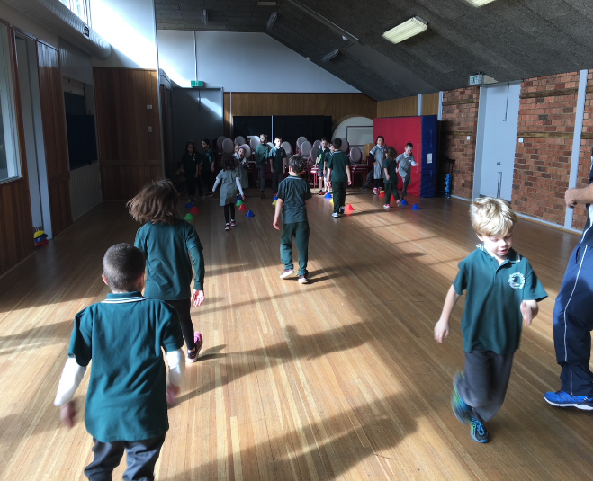

**中文 Chinese**

Last week, the students were very excited to have the Chinese students from Beijing visiting our classes. They joined us playing a game of Chinese Jump Rope in the basketball court. Students learnt about the rules and followed the steps for the game. It was great to see them working as a team, encouraging one and other to achieve their very best.

**Tanya Dulics**

Chinese Language Teacher

# 

**Library News**



During the week Monday August 20th- Friday August 24th we will be celebrating Book Week at G.P.S. **Book Week** is the week when the **Children’s Book Council of Australia** announces the winners for the best of Australian children’s literature that was published in 2017.

I will be sending home a **flyer** in the next couple of weeks outlining the events that will take place. There will also be a **competition** that the children can take part in if they like. There will be a prize of a $10 gift voucher for the winners to spend at the Book Fair. Winners will be announced on the morning of the **Book Parade [Friday 24th].** All competition answer sheets can be placed in a box outside the library. The box will be in place from **Thursday 16th till Thursday 23rd August.**

One of the activities is a **Book Fair** organised through Scholastic. We have booked a Book Fair that will run from the afternoon of **Tuesday 21st August** until the afternoon of **Friday 24th**. This is a great way to purchase a book and also support the school, as we raise money from the total of items sold. This takes the place of our Book Club that we hold each term.

Of course we will be once again holding a **Multi-Age Day** where the children work on activities linked to the short listed books. They will be in groups comprised of children from all grade levels.

**We will require volunteers to assist with Book Fair. If you are able to help can you please fill in the table below or at the end of the newsletter and return it to the office as soon as possible.**

**✂**

**Book Fair Volunteer Timetable**

**Name………………………………………**

**Phone number………………………………….**

|  |  |  |
| --- | --- | --- |
|  | **AM 8.30-9.00** | **PM 3.30-4.00** |
| **Tuesday 21st** |  |  |
| **Wednesday 22nd** |  |  |
| **Thursday 23rd** |  |  |
| **Friday 24th** |  |  |
|  |  |  |

**Overdue/Lost books**

Recently I have been sending home overdue notes. After a period of time books that are missing are declared lost and we ask for money to replace the lost book. The school policy is that we ask for 50% of the cost of the book. You are most welcome to pay for the full cost. If you think that the books that I have sent notes home for are at school, please send me a note and I will look for them. Mistakes do happen!

**Library Helpers**

An enormous thank you to Sharyn McDonald [Ben in Grade 5’s mum] who has volunteered her services to assist in the library on Wednesday mornings. If anyone else would like to assist in the library you are always welcome. Please contact me via the office.

**Premiers’ Reading Challenge**

Please feel free to visit the library to borrow books for the Premiers’ Reading Challenge, I am quite happy to send home a bulk loan of books. The children have until the 8th September to complete the challenge.

**Library open hours**

A reminder that the library is open before school on Tuesday mornings and after school on Tuesday

and Wednesday. Please feel free to drop in.

****Happy Reading

**Jen Farley**

Librarian

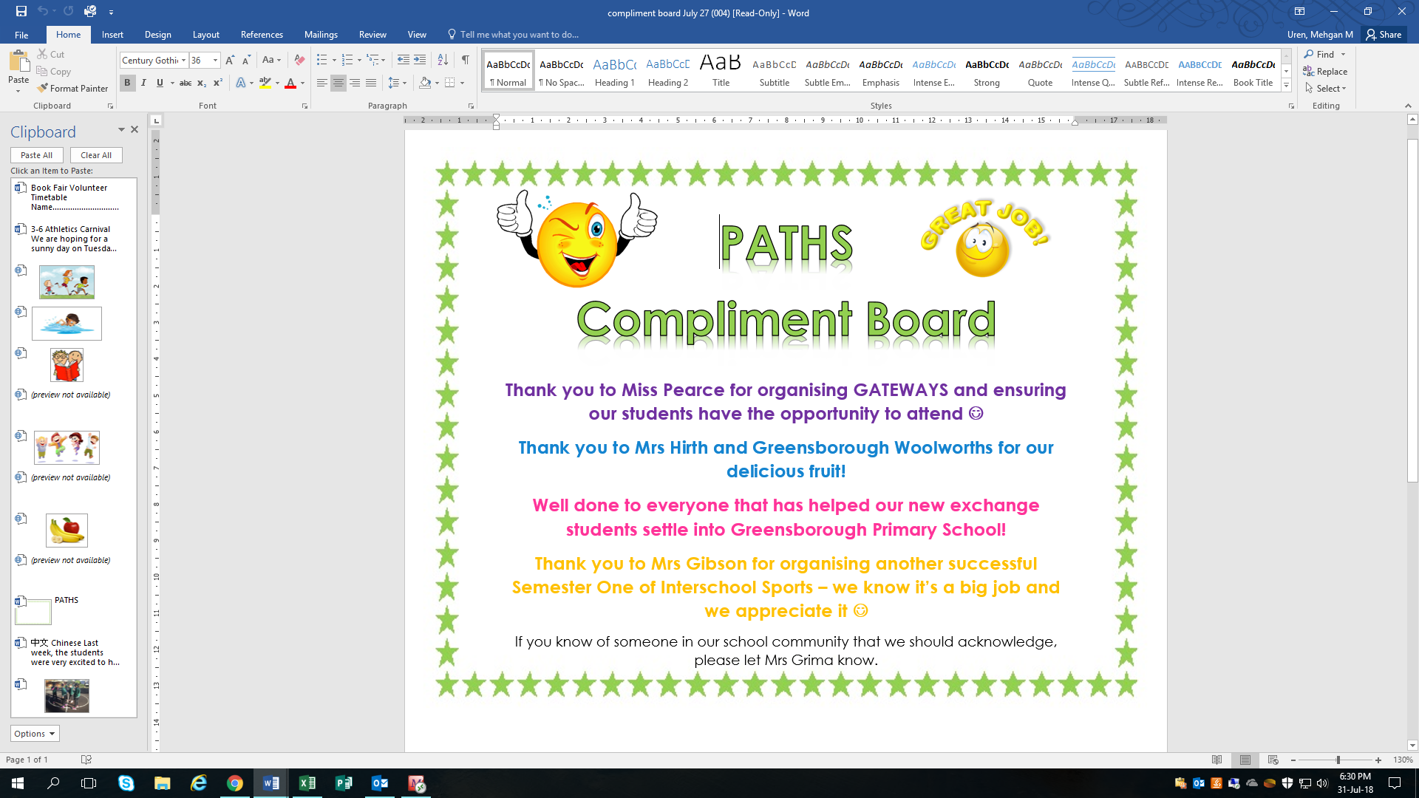

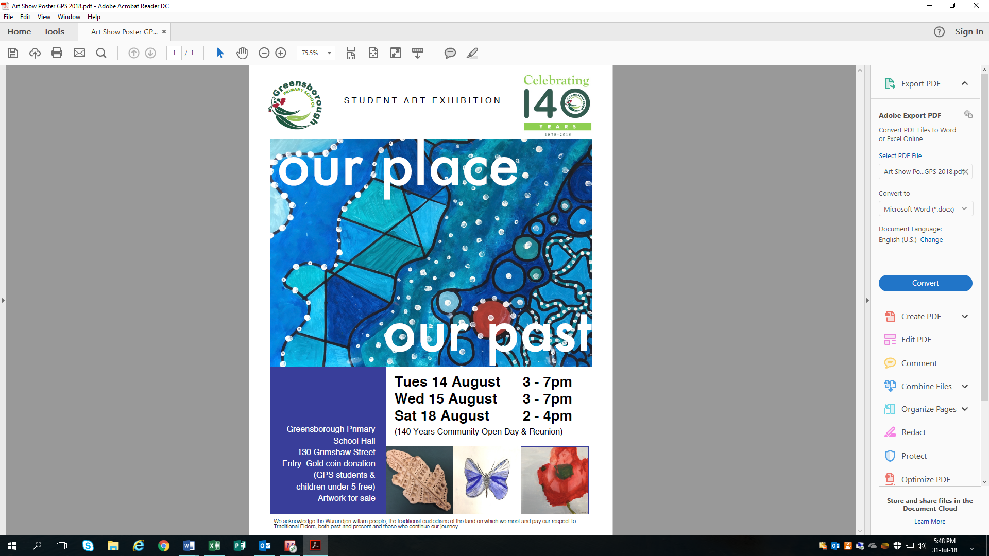

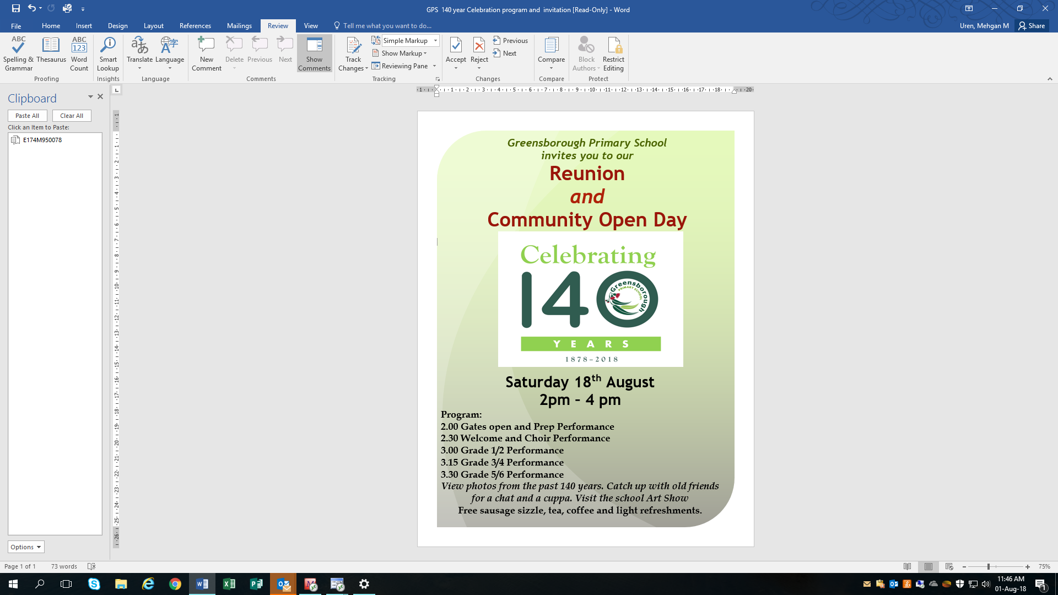

**Parents & Friends**

**Food Days**

There will be no food days for the next several weeks due to current volunteers being unavailable to assist. If you would be interested in helping (usually 9-10.30am), please let either myself or the front office know.



**Scouts Raffle**

Due back by FRIDAY 3rd Aug

Once again we are taking part in the Scouts School Raffle. With every ticket sold ($2.00) the school receives $1.50. First prize is a car, plus many more prizes on offer!

Thank you to those who have already returned their ticket books. All tickets (sold or unsold) need to be returned back to the school by this Friday 3rd August.

**Bunnings BBQ**

Saturday 8th of September – Eltham Bunnings

This years Bunnings BBQ is on Saturday 8th of September. We will be needing volunteers to help assist with this event on the day. If you are able to spare a couple of hours we would greatly appreciate it. A notice will come home asking for volunteers next week.

**Entertainment Books**

This year we are selling entertainment books. The purchase price is $70, of which the school will receive 20%. A demo copy of the box is available at the office for those who would like to see what deals are available.

Hard copy books are available at the office or alternatively you can purchase a digital copy via www.entertainmentbook.com.au/orderbooks/189481

For further information, please contact Cassie Fox (mum of Josh in 1/2B) via the front office.

**Next meeting**

Our next meeting will be Monday 6th of August @ 9:30am in the staff room. We will be planning events for this half of the year, including Bunnings BBQ. Newcomers are more than welcome to attend, as are younger children.

Thank you

**Kim Hill**

On behalf of Parents & Friends

**Community Corner**

**Wool Donations**

We are planning to decorate/yarn bomb the Friendship Tree and would love your help!

If you have any spare wool that you would like to donate to the school, or help with knitting, please see Ros M. or Simone W. Any wool donations can be placed in the box in the foyer

Thank you

**Simone Wilson**



**Pupil of the Week**

**Term 3** ~ **Week 1 Week Ending 20 July 2018**

|  |  |  |
| --- | --- | --- |
| Prep | Jett | For his wonderful knowledge of the past during our History Unit |
| Grade 1/2A | Tahlia | For always trying her best and being a kind friend |
| Grade 1/2 B | Nala | For using her senses to visualise and understand poetry |
| Grade 3/4 A | Viviarna | For making a positive start to Term 3. Keep it up Vivi! |
| Grade 3/4 B | Kleio | For coming back from holidays inspired and making a ‘fly-in’ start (it’s a flying pun!) |
| Grade 5/6 A | Jack C. | For his wonderful contributions during our Poetry Unit. Well done! |
| Grade 5/6 B | Holly-Anne | For the effort she puts in to all classroom tasks. You’re a ★Holly-Anne |
| Art | Olivia N. | For always achieving excellent results in the Art Room |
| Chinese | Joel L. | For always approaching his learning with enthusiasm |
| PE | Olivia H. | For doing a great job during high jump in PE. Well done! |

**Term 3** ~ **Week 2 Week Ending 27 July 2018**

|  |  |  |
| --- | --- | --- |
| Prep | Maisie G. | For working hard to learn her Magic Words. You are doing a great job! |
| Grade 1/2A | Liam | For working hard during writing and his fantastic senses poem about the seasons |
| Grade 1/2 B | James | For using his prior knowledge to engage in classroom discussions about Aboriginal and Torres Strait Islander culture |
| Grade 3/4 A | Amber | For her amazing positive attitude towards her learning |
| Grade 3/4 B | Ella F. | For her application to her reading in the Premier’s Reading Challenge and great start to Term 3 |
| Grade 5/6 A | Sophie C. | For her outstanding work during Big Write, writing a well structured, rhyming poem! ★ |
| Grade 5/6 B | Sam | For being such a great English teacher to our new classmate |
| Art | Will D. | For a fantastic effort with your sewing in Art |
| Chinese | Riley Mc. | For great effort and pride in his contributions during Chinese |
| PE | Abbey C. | For taking on board feedback during shot put and doing a great job practising. Well done! |
| Music | Starr | Well done for embracing our music program this term, especially in choir and Ukulele extension time |

Do you have any old sheets, pillow cases, tablecloths, tea towels or clothes that you would like to get out of your cupboards but don’t want to throw in landfill?

The answer to this dilemma is Boomerang Bags! We will take your old material that has served its first purpose and give it new purpose as gorgeous, individualised and creative shopping bags, which you can be proud of using instead of single-use plastic bags.

Greenhills Neighbourhood House is asking for your material donations or assistance for their group on:

**Term 3 on Thursdays 12.30-2.30pm (bring your lunch).**

There is a box in the office to put your donations in. Other sewing accessories are also welcome.

Please talk to Megan Cassidy (Charlotte’s mum in Prep) if you have any questions, or email [sustainablegreensie@gmail.com](mailto:sustainablegreensie@gmail.com). If you would like to join the group on Thursdays, call the Greenhills Neighbourhood House on 9435 9287 to register.

*Sustainable Greensborough: Developing a thriving community through positive local action*

Thank you for your support.

**Megan C.**



Diamond Valley Community Support is an emergency relief, support, information and referral agency. We are community based and not-for-profit and support families and individuals in the Banyule area.

Our services are free, confidential, impartial and independent. We respect everyone's right to make their own decisions.

### Our Services include:

* Provision of Emergency Aid
* Personal Counselling
* Financial Counselling
* Information & Referral

**Tax Help**

* You may be eligible for FREE help with your tax return.
* 24th July – 30th October 2018
* Contact details below

**Diamond Valley Community Support Inc.**  
Shop 378a, Level 3  
Greensborough Plaza  
Greensborough 3088 **Telephone: 03 9435 8282**