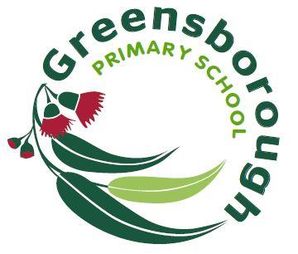 | Greensborough Primary School  2062  Uniform Price List 2022
Child’s Name: ………………………………….……………………Grade: ………………….
TYPE |  | SIZES | PRICE | QUANTITY | SIZE | TOTAL | TAKEN
Polo Shirts (Short sleeve) |  | 4 -16C | 26.00
Polo Shirts (Short sleeve) Adult |  | 14 -16A | 30.00
Grey Gabardine Shorts |  | 4 -16C | 24.00
Shorts Green (Drawstring) |  | 4 -16C | 18.00
Track pants Green |  | 4 -16C | 20.00
Windcheater (Crew neck) |  | 6 -16C | 25.00
Windcheater (Crew neck) |  | 14 -16A | 33.00
Bomber Jackets Unlined |  | 4 -16C | 43.00
Bomber Jackets By order only  (Please note this item is not held in stock) |  | 14 -18A | 49.00
Hats Slouch |  | S M  L XL | 12.00
Reader Bag |  |  | 13.00
School Backpack with Logo Flap (Student friendly) |  |  | 75.00
Date Paid: / / Total: |  |  |  |  |  | $
Parent/Guardian’s Signature: …………………………………………………
Office Use:

