**YARD DUTY AND SUPERVISION POLICY**

**PURPOSE**

To ensure school staff understand their supervision and yard duty responsibilities.

**SCOPE**

This policy applies to all teaching and non-teaching staff at Greensborough Primary School, including education support staff, casual relief teachers and visiting teachers.

**POLICY**

Appropriate supervision is an important strategy to monitor student behaviour and enables staff to identify and respond to possible risks at school as they arise. It also plays a vital role in helping schools to discharge their duty of care to students.

The Principal is responsible for ensuring that there is a well organised and responsive system of supervision and yard duty in place during school hours, before and after school, and on school excursions and camps and other school activities.

School staff are responsible for following reasonable and lawful instructions from the principal, including instructions to provide supervision to students at specific dates, time and places. Supervision should be undertaken in a way that identifies and mitigates risks to child safety.

**POLICY**

### **Before and after school**

Greensborough Primary School’s grounds are supervised by school staff from 8.45am until 3.45pm. Outside of these hours, school staff will not be available to supervise students. Before school, school staff will be available to monitor the whole yard. After school, rostered staff will roam the whole yard once and collect students who have not been collected by a parent and take them to the office by 3.45pm and notify the business manager to make a phone call to parents/guardians.

Parents and carers should not allow their children to attend Greensborough Primary School outside of these hours. Families are encouraged to contact OSHClub on 1300 395 735 or refer to oshclub.com.au for more information about the before and after school care facilities available to our school community.

If a student arrives at school before supervision commences at the beginning of the day, the principal or nominee staff member will, as soon as practicable, follow up with the parent/carer to:

* advise of the supervision arrangements before school
* request that the parent/ carer make alternate arrangements.

If a student is not collected before supervision finishes at the end of the day, the principal or nominee staff member will consider whether it is appropriate to:

* attempt to contact the parents/carers
* attempt to contact the emergency contacts
* place the student in an out of school hours care program (if available)
* contact Victoria Police and/or the Department of Health and Human Services (Child Protection) to arrange for the supervision, care and protection of the student.

School staff who are rostered on for before or after school supervision must follow the processes outlined below.

### **Yard duty**

All staff at Greensborough Primary School are expected to assist with yard duty and First Aid supervision and will be included in the weekly roster.

The principal is responsible for preparing and communicating the yard duty roster on a regular basis. At Greensborough Primary School, school staff will be designated a specific yard duty area to supervise.

**Yard duty zones**

The designated yard duty areas for our school are:

The designated yard duty areas for our school as at Term 2, 2023 are:

|  |  |
| --- | --- |
| **Zone** | **Area** |
| Upper Yard | From Library Outdoor Area to Junior Playground |
| Lower Yard | From Friendship Tree to Outside 5/6A |
| With Student/s | As required indoor/outdoor |



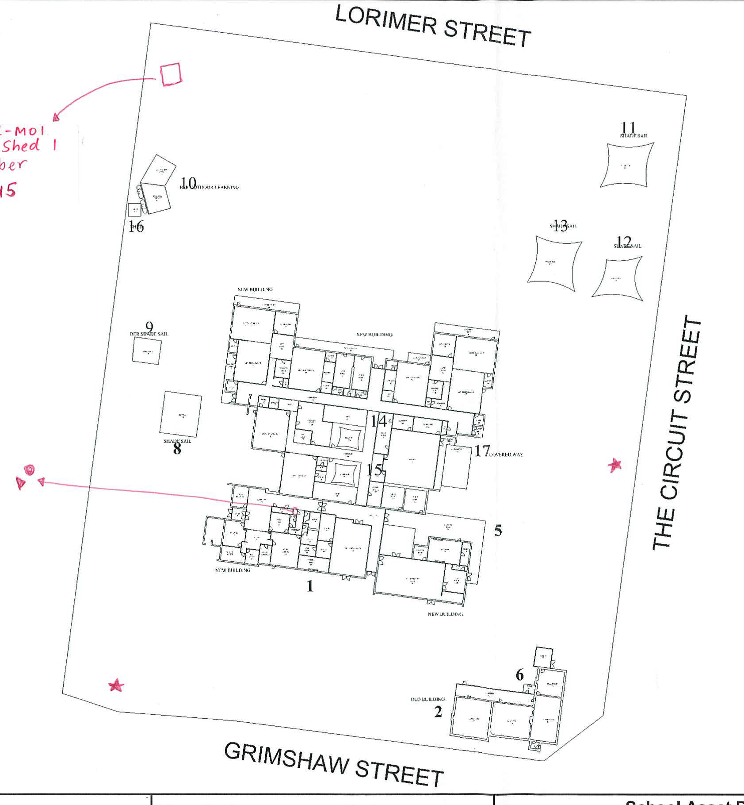

School staff must:

* wear a provided safety/hi-vis vest whilst on yard duty. Safety/hi-vis vests will be distributed to staff for personal use and storage.
* Carry a yard duty first aid bag at all times during supervision. The yard duty first aid bag will be stored in the classroom or easily accessible location for class and specialist teachers.
* Yard duty equipment must be returned after the period of supervision or handed to the relieving staff member.

**Yard duty responsibilities**

Staff who are rostered for yard duty must remain in the designated area until they are replaced by a relieving teacher.

During yard duty, supervising staff must:

* methodically move around the designated zone *whole yard* ensuring all areas within the school zone are monitored and out of bounds areas are enforced
* be alert and vigilant
* where safe to do so, approach any unknown visitor who is observed on school grounds without a clear legitimate purpose, and ensure they have a visitor pass and have signed in (excluding drop off and collection periods)
* ensure students remain in their designated playground zones
* intervene immediately if potentially dangerous or inappropriate behaviour is observed in the yard
* enforce behavioural standards and implement appropriate consequences for breaches of safety rules, in accordance with any relevant disciplinary measures set out in your school’s *Student* *Engagement and Wellbeing* policy
* ensure that students who require first aid assistance receive it as soon as practicable
* log any incidents or near misses as appropriate on Compass
* if being relieved of their yard duty shift by another staff member (for example, where the shift is ‘split’ into 2 consecutive time periods), ensure that a brief but adequate verbal ‘handover’ is given to the next staff member in relation to any issues which may have arisen during the first shift.

If the supervising staff member is unable to conduct yard duty at the designated time, they should make alternative relevant yard duty changes and write these changes on the whiteboard.

If the supervising staff member needs to leave yard duty during the allocated time, they should contact the Principal or officebut should not leave the designated area until the relieving staff member has arrived in the designated area.

If a relieving or next staff member does not arrive for yard duty, the staff member currently on duty should contact the office and not leave the designated area until a replacement staff member has arrived.

Should students require assistance during recess or lunchtime, they are encouraged to speak to the supervising yard duty staff member.

### **Classroom**

The classroom teacher is responsible for the supervision of all students in their care during class.

If a teacher needs to leave the classroom unattended at any time during a lesson, they should first contact the closest teacher for assistance.

### **School activities, camps and excursions**

The principal and leadership team are responsible for ensuring that students are appropriately supervised during all school activities, camps and excursions, including when external providers are engaged to conduct part or all of the activities. Appropriate supervision will be planned for special school activities, camps and excursions on an individual basis, depending on the activities to be undertaken and the level of potential risk involved and will follow the supervision requirements in the Department of Education and Training Excursions Policy.

## Digital devices and virtual classroom

Greensborough Primary School follows the Department’s [Cybersafety and Responsible Use of Technologies Policy](https://www2.education.vic.gov.au/pal/cybersafety/policy) with respect to supervision of students using digital devices.

Greensborough Primary School will also ensure appropriate supervision of students participating in remote and flexible learning environments while on school site. In these cases, students will be supervised e.g. the library/break out space/ common area

While parents are responsible for the appropriate supervision of students accessing virtual classrooms from home:

* student attendance will be daily
* any wellbeing or safety concerns for the student will be managed in accordance with our usual processes – refer to our Student Wellbeing and Engagement Policy and our Child Safety Responding and Reporting Policy and Procedures for further information.

## Students requiring additional supervision support

Sometimes students will require additional supervision, such as students with disability or other additional needs. In these cases, the Principal or delegate will ensure arrangements are made to roster additional staff as required. This may include on yard duty, in the classroom or during school activities.

## Supervision of student in emergency operating environments

In emergency circumstances our school will follow our Emergency Management Plan, including with respect to supervision.

In the event of any mandatory period of remote or flexible learning our School will follow the operations guidance issued by the Department.

**COMMUNICATION**

This policy will be communicated to our school community in the following ways:

* Included in staff induction processes
* Discussed at staff briefings or meetings, as required
* Included on staff Google drive
* Made available in hard copy from school administration upon request

Information for parents and students on supervision before and after school is available on our school website and parent reminders are sent each term in our school newsletter.

**FURTHER INFORMATION AND RESOURCES**

* School Policy and Advisory Guide:
  + [Supervision](http://www.education.vic.gov.au/school/principals/spag/safety/pages/supervision.aspx)
  + [Duty of Care](http://www.education.vic.gov.au/school/principals/spag/safety/Pages/dutyofcare.aspx)
  + [Child Safe Standards](http://www.education.vic.gov.au/school/principals/spag/safety/Pages/childsafestandards.aspx)
  + [Visitors in Schools](http://www.education.vic.gov.au/school/principals/spag/safety/Pages/visitorsinschool.aspx)
* The Department’s Policy and Advisory Library (PAL):
  + [Child Safe Standards](https://www2.education.vic.gov.au/pal/child-safe-standards/policy)
  + [Cybersafety and Responsible Use of Technologies](https://www2.education.vic.gov.au/pal/cybersafety/policy)
  + [Duty of Care](https://www2.education.vic.gov.au/pal/duty-of-care/policy)
  + [Excursions](https://www2.education.vic.gov.au/pal/excursions/policy)
  + [Supervision of Students](https://www2.education.vic.gov.au/pal/supervision-students/policy)
  + [Visitors in Schools](https://www2.education.vic.gov.au/pal/visitors/policy)
  + [Work Experience](https://www2.education.vic.gov.au/pal/work-experience/policy)

**POLICY REVIEW AND APPROVAL**

|  |  |
| --- | --- |
| Policy last reviewed | June 2023 |
| Approved by | Principal |
| Next scheduled review date | May 2024 the recommended minimum review cycle for this policy is 1 year |

* This policy will also be updated if significant changes are made to school grounds that require a revision of Greensborough Primary School’s yard duty and supervision arrangements.